**AI-Generated Multiple Choice Questions from  
RadioGraphics Top 10 Reading List  
(Gastrointestinal Imaging - Intermediate)**

# Question 1:

A 72-year-old woman presents with diffuse abdominal pain and hypotension. Based on the findings in the provided figure, what is the likely diagnosis?

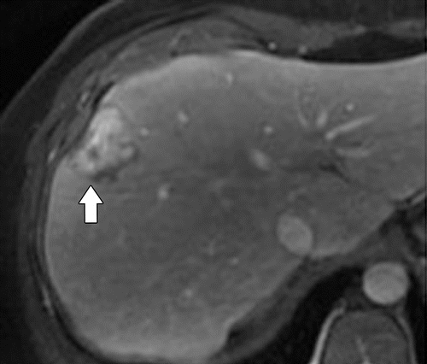

# Answer:

Acute mesenteric ischemia with small-bowel infarction

Source: Imaging of Drug-induced Complications in the Gastrointestinal System _ RadioGraphics.html

---Original Figure Caption:

Figure 14a.HCAin a 24-year-old woman taking oral contraceptive pills who presented for imaging follow up. Axial arterial phase(a), portal venous phase(b), and 1-hour delayed phase(c)MR images obtained with hepatocyte-specific gadolinium contrast agent show a liver lesion in the right lobe (arrow) with early arterial enhancement that persists in the portal venous phase. The late persistent enhancement seen at the periphery incis due to a ductular reaction (proliferation of ductular structures from a large duct obstruction). Pathologic analysis of a surgical tissue sample showedHCA, inflammatory subtype.

# Question 2:

A 75-year-old woman presents with epigastric pain. The intraoperative photograph provided shows an important finding. What type of hernia is suggested by the presence of incarcerated intestine in front of the lesser omentum?

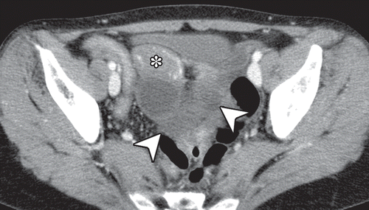

# Answer:

Combined lesser sac hernia

Source: Internal Hernias in the Era of Multidetector CT_ Correlation of Imaging and Surgical Findings _ RadioGraphics.html

---Original Figure Caption:

Figure 18b.Broad ligament hernia in a 58-year-old woman with a 1-day history of intermittent abdominal pain and vomiting and a history of three normal pregnancies.(a, b)Axial contrast-enhanced CT images obtained at different levels show a cluster of small bowel loops in the pouch of Douglas (arrowheads) and crowding mesenteric vessels (arrows). The uterus (*) is deviated inferiorly and to the right.(c)CoronalMPRCT image shows the hernia orifice (white arrows) below the tubal and ovarian branches (black arrow) of the left ovarian and uterine vessels. Enlargement of the distance between the uterus (*) and the left ovary (arrowhead) is also seen. The patient’s abdominal pain acutely intensified, and open surgery was performed.(d)Intraoperative photograph (anterior view) shows incarceration of the small intestine through a thumb-tip–sized defect (arrows) in the left broad ligament of the uterus. Approximately 70 cm of incarcerated intestine was infarcted and was resected, and the broad ligament was sectioned. (Fig 18a and 18d adapted and reprinted, with permission, from reference68. Fig 18b and 18c courtesy of Yukio Nishiguchi, MD, Osaka City General Hospital, Osaka, Japan, and Tetsuro Ikeya, MD, Osaka City University Graduate School of Medicine, Osaka, Japan.)

# Question 3:

A 58-year-old man with cirrhosis resulting from hepatitis C infection presents with a spontaneous splenorenal shunt. On the Coronal T2-weighted MR image, what tortuous structure can be seen arising from the left renal vein and coursing within the splenorenal ligament toward the splenic hilum?

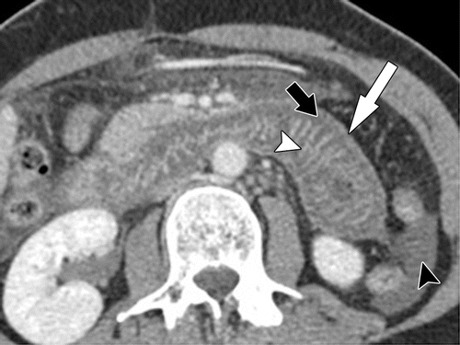

# Answer:

Splenorenal shunt

Source: Imaging of Drug-induced Complications in the Gastrointestinal System _ RadioGraphics.html

---Original Figure Caption:

Figure 7.ACEinhibitor–induced angioedema in a 50-year-old woman who developed crampy abdominal pain and vomiting 2 days after startingACE-inhibitor therapy for hypertension. Axial contrast-enhanced CT image shows mural stratification in the duodenum and jejunum, with low-attenuating submucosal edema (black arrow) adjacent to hyperemic enhancing mucosal (white arrowhead) and serosal (white arrow) layers. A small amount of ascites (black arrowhead) is seen.

# Question 4:

A 55-year-old man presents with a history of acid reflux. A double-contrast esophagram is provided. What is the most specific radiographic finding for the suspected condition?

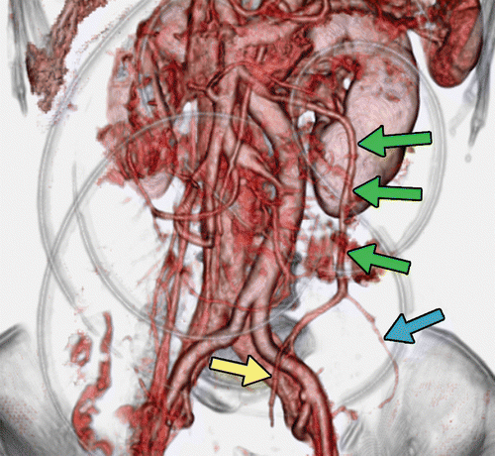

# Answer:

Midesophageal stricture

Source: Internal Hernias in the Era of Multidetector CT_ Correlation of Imaging and Surgical Findings _ RadioGraphics.html

---Original Figure Caption:

Figure 15c.Intramesosigmoid hernia in a 56-year-old woman with acute abdominal pain and vomiting.(a)Axial contrast-enhanced CT image shows incarcerated intestine within a sac (arrowheads) and enlarged, stretched mesenteric vessels in the hernia orifice between the sigmoid colon (*) and left psoas major muscle (★). The hernia orifice also separates the sigmoid vessels (white arrows) and superior rectal vessels (black arrow).(b)CoronalMPRCT image shows sigmoid and superior rectal vessels (arrows) wrapping the hernia sac (arrowheads) visually.(c)Portal venous phase3DCT angiogram clearly depicts the separation of one of the sigmoid veins (blue arrow) and the superior rectal vein (yellow arrow). Green arrows = inferior mesenteric vein.(d)Intraoperative photograph (anterior view) after reduction shows a 2-cm-diameter defect (arrow) in only one peritoneal layer of the sigmoid mesocolon (*).The defect was surgically closed.S= sigmoid colon. (Fig 15a, 15b, and 15d adapted and reprinted, with permission, from reference58. Fig 15c courtesy of Hironori Shigeoka, MD, Osaka Prefectural Medical Center for Respiratory and Allergic Diseases, Habikino, Japan.)

# Question 5:

A 65-year-old woman presents with chronic heartburn and difficulty swallowing. A CT scan of the esophagus is provided. What condition is the figure most likely indicative of?

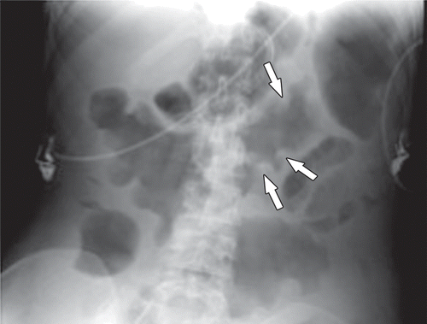

# Answer:

Hiatal hernia and reflux esophagitis

Source: Imaging of Drug-induced Complications in the Gastrointestinal System _ RadioGraphics.html

---Original Figure Caption:

Figure 10b.Pseudomembranous colitis.(a)Image from colonoscopy in a 52-year-old man who presented with profuse diarrhea shows superficial ulcerations with overlying yellow-white plaques that correspond to pseudomembranes.(b)Abdominal radiograph in a 59-year-old woman who presented with diarrhea shows diffuse thickening of the colon wall with thumbprinting (arrows). The patient was taking cephalosporin for a urinary tract infection.(c)Pathologic specimen from colon resection in a 44-year-old woman with toxemia shows colonic mucosa with diffuse active colitis and polypoid pseudomembranes.(d)Axial contrast-enhanced CT image in a 62-year-old woman with a history of pneumonia treated with clindamycin who presented with diarrhea shows pseudomembranous colitis with pancolitis. There is marked diffuse thickening of the colon wall with submucosal edema (white arrow) and diffuse mucosal hyperemia (black arrow).

# Question 6:

A 55-year-old patient presented with chronic heartburn and dysphagia. You suspect a hiatal hernia. Based on the spot radiograph of the GEJ provided in the figure, what is the relationship between the esophageal hiatus and the diaphragmatic shadow?

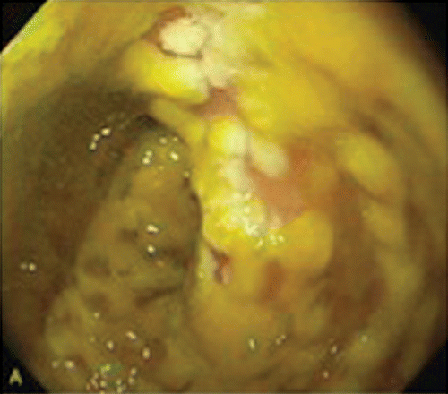

# Answer:

The hiatus does not correlate with the diaphragmatic shadow

Source: Imaging of Drug-induced Complications in the Gastrointestinal System _ RadioGraphics.html

---Original Figure Caption:

Figure 10a.Pseudomembranous colitis.(a)Image from colonoscopy in a 52-year-old man who presented with profuse diarrhea shows superficial ulcerations with overlying yellow-white plaques that correspond to pseudomembranes.(b)Abdominal radiograph in a 59-year-old woman who presented with diarrhea shows diffuse thickening of the colon wall with thumbprinting (arrows). The patient was taking cephalosporin for a urinary tract infection.(c)Pathologic specimen from colon resection in a 44-year-old woman with toxemia shows colonic mucosa with diffuse active colitis and polypoid pseudomembranes.(d)Axial contrast-enhanced CT image in a 62-year-old woman with a history of pneumonia treated with clindamycin who presented with diarrhea shows pseudomembranous colitis with pancolitis. There is marked diffuse thickening of the colon wall with submucosal edema (white arrow) and diffuse mucosal hyperemia (black arrow).

# Question 7:

A 52-year-old patient presents with a history of solid food dysphagia and food impaction. Given the photomicrograph provided, what histological features would you expect to observe in a patient with these symptoms?

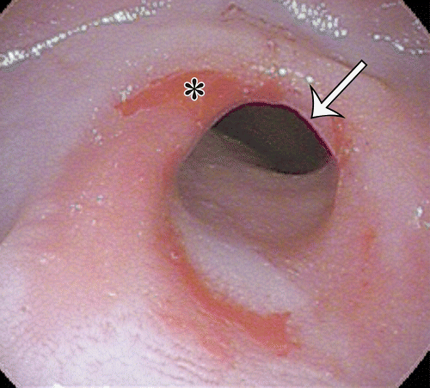

# Answer:

Histological features indicative of chronic inflammation and intestinal metaplasia

Source: Role of Multimodality Imaging in Gastroesophageal Reflux Disease and Its Complications, with Clinical and Pathologic Correlation _ RadioGraphics.html

---Original Figure Caption:

Figure 11c.Peptic stricture.(a)Photomicrograph of the esophagus shows diffuse deposition of pink-stained fibrous tissue (curved arrows) in the splayed muscularis propria (straight arrow). There is lymphocytic infiltration of the lamina propria and epithelium (circle), which is now composed of glands containing goblet cells (arrowheads), indicative of chronic inflammation and intestinal metaplasia. (H-E stain; original magnification, ×40.)(b)Photograph of a gross specimen shows a focal area of luminal narrowing (arrows) just above the squamocolumnar junction.(c)Endoscopic image shows a focal area of smooth narrowing (arrow) adjacent to nodular reddened mucosa, consistent with erosive esophagitis. Note the finger-like projections of salmon-colored velvety mucosa (*), consistent with areas of Barrett esophagus.(d)Prone single-contrast radiograph shows smooth concentric narrowing of the midesophagus (arrows) with a tiny outpouching of contrast material (intramural pseudodiverticulosis).

# Question 8:

A 24-year-old woman taking oral contraceptive pills presents for imaging follow up. Based on the imaging findings provided in the figure, what is the subtype of the Hepatocellular adenoma (HCA)?

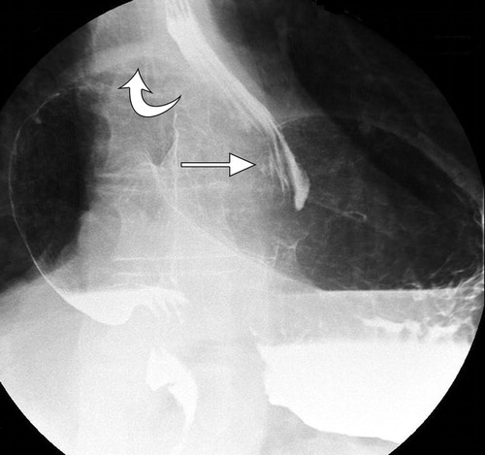

# Answer:

Inflammatory subtype

Source: Surgical Approach to Gastroesophageal Reflux Disease_ What the Radiologist Needs to Know _ RadioGraphics.html

---Original Figure Caption:

Figure 13.Type IV hernia (intrathoracic stomach). Spot radiograph reveals a large hernia, with the majority of the stomach lying in the chest and displacing the distal esophagus (straight arrow). The intrathoracic stomach usually rotates 180° along its longitudinal axis, resulting in the displacement of the greater curvature (curved arrow) superior to the lesser curvature.

# Question 9:

A patient presents with upper abdominal fullness and inability to belch after a Nissen fundoplication. On the radiograph of the esophagus, what abnormal finding can be seen at the distal esophagus and GEJ?

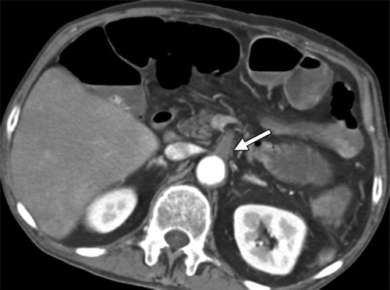

# Answer:

Narrowing

Source: CT Findings of Acute Small-Bowel Entities _ RadioGraphics.html

---Original Figure Caption:

Figure 2a.Acute mesenteric ischemia due to SMA thrombosis in a 62-year-old man who presented with severe abdominal pain. Axial intravenous contrast-enhanced CT images show a thrombus (arrow ina) at the SMA origin, with absence of enhancement and several dilated paper-thin loops of jejunum with high-attenuation layering intraluminal fluid (arrowheads inb) corresponding to hemorrhagic infarction, which was confirmed at surgery.

# Question 10:

A 58-year-old man with metastatic renal cell carcinoma presents with abdominal pain and diarrhea. A coronal oral and intravenous contrast-enhanced CT image is provided. What specific imaging feature, indicated by arrows in the figure, supports the diagnosis of Sunitinib-related enteritis?

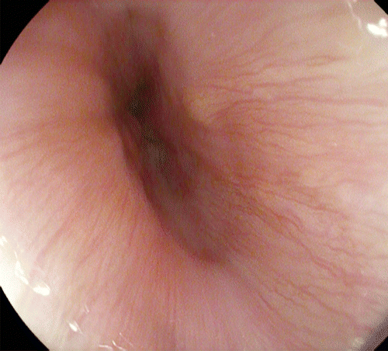

# Answer:

Mural stratification

Source: Role of Multimodality Imaging in Gastroesophageal Reflux Disease and Its Complications, with Clinical and Pathologic Correlation _ RadioGraphics.html

---Original Figure Caption:

Figure 4b.Multimodality appearance of the EGJ. The LES is defined functionally and is difficult to precisely identify anatomically, radiographically, and endoscopically.(a)Photograph of gross specimen of EGJ shows transition from the tan-white esophageal squamous mucosa to the velvet red columnar mucosa of the gastric cardia (arrow), but there is no focal muscular thickening in the relaxed state to anatomically denote the location of the LES.(b)Endoscopic image of the normal EGJ shows thin longitudinal vessels visible through the squamous epithelium. Endoscopically, the EGJ can be defined as the lower limit of the longitudinal vessels.(c)Single-contrast esophagram shows contrast material distending the distal esophagus, with tapering of the lower esophagus in the expected subdiaphragmatic location of the LES (arrow) and with contrast material and air filling the gastric cardia and fundus. During swallowing, the LES relaxes, allowing the contrast material bolus to pass through the EGJ (arrow) into the stomach.(d)Coronal oblique CT image shows the anatomy of the distal esophagus and EGJ. There is focal widening of the relaxed LES compared with the esophageal body (referred to as the ampulla or vestibule), and the inferior edge of the ampulla represents the EGJ (arrow).

# Question 11:

A 59-year-old man taking clindamycin presents with dysphagia. Based on the double-contrast esophagram (profile view) provided in the figure, what specific imaging finding is consistent with an ulcer?

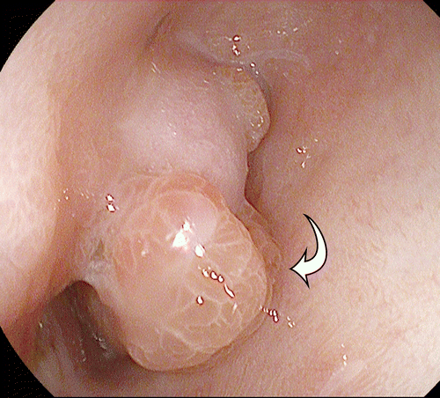

# Answer:

Elongated, flat, plaquelike filling defect

Source: Role of Multimodality Imaging in Gastroesophageal Reflux Disease and Its Complications, with Clinical and Pathologic Correlation _ RadioGraphics.html

---Original Figure Caption:

Figure 15c.Esophageal adenocarcinoma.(a)Photomicrograph shows the changes associated with progression to adenocarcinoma, with back-to-back irregularly shaped glands of varying size containing hyperchromatic nuclei (curved arrow) within the mucosa and infiltrating into the lamina propria and muscularis (straight arrow). Note the extensive fibrosis (*). (H-E stain; original magnification, ×100.)(b, c)Endoscopic images show flat mucosal nodules (arrow inb) on a background of Barrett esophagus (* inb) and a larger polypoid intraluminal mass (arrow inc) causing luminal narrowing.(d)Endoscopic US image accurately shows the depth of tumor invasion. The hyperechoic tumor (*) disrupts alternating rings of hyperechoic superficial mucosa, hypoechoic deep mucosa, hyperechoic submucosa, and hypoechoic muscularis propria (arrowheads), with minimal extension into the hyperechoic adventitia.

# Question 12:

A patient presents with a history of chronic reflux esophagitis. Based on the figure provided, what is the visualized abnormality in the esophagus that could be a result of this chronic condition?

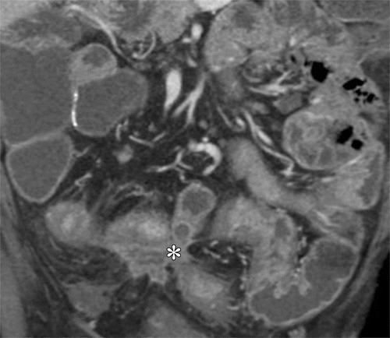

# Answer:

Barrett esophagus

Source: CT Findings of Acute Small-Bowel Entities _ RadioGraphics.html

---Original Figure Caption:

Figure 22.Crohn disease with fistula formation in a 68-year-old man. Coronal intravenous contrast-enhanced CT image shows a stellate-appearing complex enteroenteric/enterocolic fistula (*) with an inflammatory soft-tissue mass tethering several segments of adjacent colon and small bowel to a central point. Note the target appearance of the involved small bowel and the associated mesenteric edema.

# Question 13:

A 59-year-old woman presents with right lower abdominal pain. An intraoperative photograph is provided. Based on the findings, approximately how much of the gangrenous small intestine was resected?

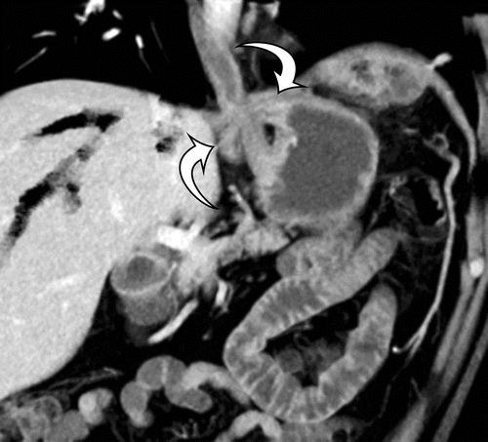

# Answer:

190 cm

Source: Role of Multimodality Imaging in Gastroesophageal Reflux Disease and Its Complications, with Clinical and Pathologic Correlation _ RadioGraphics.html

---Original Figure Caption:

Figure 7d.Hiatal hernia at CT.(a)Axial CT image without oral contrast material shows a homogeneous well-circumscribed mass (arrow) in the inferior posterior mediastinum, which exerts mass effect on the left heart.(b)Subsequent CT image with oral contrast material shows gas and contrast material distending the mass (arrow), confirming it to be a moderate hiatal hernia.(c)Sagittal CT image through the midline shows cephalic displacement of the EGJ (curved arrow) and gastric cardia (straight arrow) above the diaphragm. The distal esophagus is incompletely distended with contrast material (*).(d)Coronal oblique maximum intensity projection (MIP) CT image after Nissen fundoplication shows a short segment of the gastric fundus around the distal esophagus (arrows), reinforcing the EGJ to restore the physiologic equivalent of the normal LES.

# Question 14:

In the context of a patient with a shortened esophagus, what surgical procedure might be required to prevent a recurrent hiatal hernia and failed fundoplication, as illustrated in the provided figure?

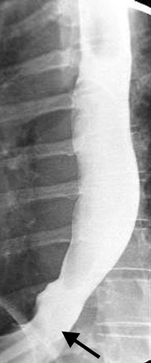

# Answer:

Collis gastroplasty

Source: Surgical Approach to Gastroesophageal Reflux Disease_ What the Radiologist Needs to Know _ RadioGraphics.html

---Original Figure Caption:

Figure 10b.Reducible type I hiatal hernia.(a)Spot radiograph of the proximal stomach obtained with the patient supine shows the gastric fundus (*) lying above the diaphragm.(b)On an upright radiograph, the hernia is completely reduced below the diaphragm. The GEJ (arrow) is identifiable by noting the termination point of the converging gastric folds.

# Question 15:

A 74-year-old man presents with intermittent abdominal pain. Based on the axial contrast-enhanced CT image provided, what is the diagnosis?

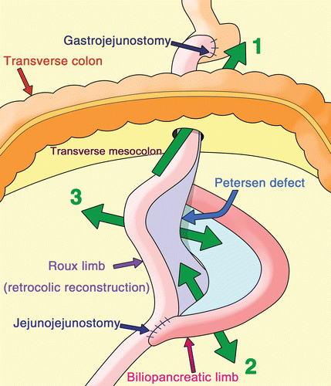

# Answer:

Foramen of Winslow hernia

Source: Internal Hernias in the Era of Multidetector CT_ Correlation of Imaging and Surgical Findings _ RadioGraphics.html

---Original Figure Caption:

Figure 20.Drawing shows the anatomic sites of transmesenteric-type internal hernias after Roux-en-Y anastomosis reconstruction:1= transmesocolic hernia,2= jejunojejunostomy mesenteric hernia,3= Petersen hernia.

# Question 16:

A patient presents with recurrent reflux symptoms following a fundoplication procedure. Based on the lateral radiograph provided in the figure, what complication is evident?

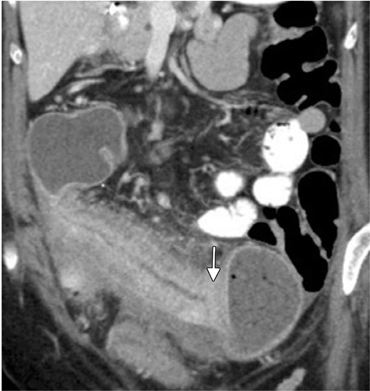

# Answer:

Slipped fundoplication

Source: CT Findings of Acute Small-Bowel Entities _ RadioGraphics.html

---Original Figure Caption:

Figure 21b.Active inflammation superimposed on stricturing Crohn disease with low-grade obstruction in two patients.(a)Coronal intravenous contrast-enhanced CT image in a 56-year-old woman shows marked wall thickening and mucosal hyperenhancement of the neoterminal ileum, with the classic comb sign representing mesenteric engorgement (arrowheads). Note the marked luminal narrowing (*) and upstream dilatation, corresponding to active stricturing Crohn disease.(b)Coronal oral and intravenous contrast-enhanced CT image in a 39-year-old woman shows marked mural thickening and hyperenhancement, with a dilated loop of ileum upstream to the inflammatory stricture (arrow).

# Question 17:

A 29-year-old woman with a history of acute myeloid leukemia presents with recurrent small-bowel obstruction 2 years after undergoing allogeneic stem cell transplant. Based on the fluoroscopic image provided, how would you describe the appearance of the small bowel?

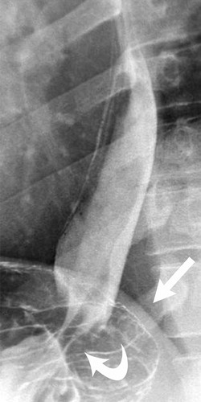

# Answer:

Toothpaste or ribbonlike

Source: Surgical Approach to Gastroesophageal Reflux Disease_ What the Radiologist Needs to Know _ RadioGraphics.html

---Original Figure Caption:

Figure 7.Spot radiograph of the GEJ reveals the pinch (curved arrow) where the lumen crosses the esophageal hiatus. Note that, in this case, the hiatus does not correlate with the diaphragmatic shadow (straight arrow).

# Question 18:

A 42-year-old woman being treated with hydrochlorothiazide, doxazosin, and estrogen replacement presents with abdominal pain. Based on the axial contrast-enhanced arterial phase CT image provided in the figure, what is the radiological finding represented by the arrow?

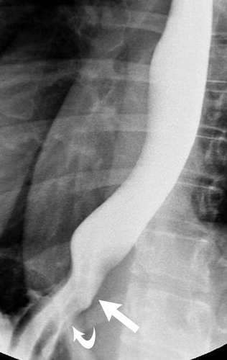

# Answer:

Large regions of increased attenuation representing congestion

Source: Surgical Approach to Gastroesophageal Reflux Disease_ What the Radiologist Needs to Know _ RadioGraphics.html

---Original Figure Caption:

Figure 6.Spot radiograph shows a normal GEJ (straight arrow), which is identified where the gastric folds terminate. The diaphragmatic hiatus (curved arrow) is located at the “pinch” where the esophageal lumen narrows as it crosses the crura. It is important to remember that the GEJ moves with change of patient position and during normal inspiration.

# Question 19:

In the context of an intramesenteric hernia, what specific imaging finding can be observed?

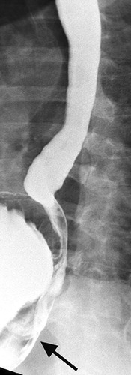

# Answer:

A saclike appearance

Source: Surgical Approach to Gastroesophageal Reflux Disease_ What the Radiologist Needs to Know _ RadioGraphics.html

---Original Figure Caption:

Figure 11b.Type II hiatal hernia (paraesophageal hernia).(a)Spot radiograph of the distal esophagus and proximal stomach reveals the entire gastric fundus (*) lying above the diaphragm. Note the pinch where the gastric folds traverse the hiatus (arrow). These findings initially seem to indicate a type I hernia.(b)Oblique radiograph shows the GEJ (arrow) coursing posterior to the herniated fundus. The GEJ actually lies at the level of the diaphragm, making this a type II hernia.

# Question 20:

A 59-year-old woman presents with right lower abdominal pain. Based on the CT images provided, what type of hernia is she most likely suffering from?

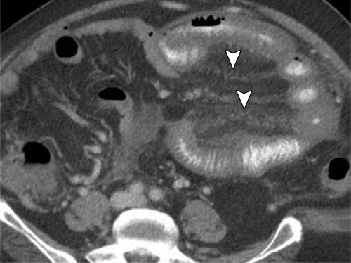

# Answer:

Transmesenteric hernia

Source: CT Findings of Acute Small-Bowel Entities _ RadioGraphics.html

---Original Figure Caption:

Figure 5b.Acute mesenteric venous ischemia in a 53-year-old man with a history of cirrhosis who presented with increasing abdominal distention and abdominal pain. Coronal(a)and axial(b)oral and intravenous contrast-enhanced CT images show an occlusive thrombus in the superior mesenteric vein (arrow ina), which is associated with diffuse circumferential small-bowel wall thickening, mesenteric edema (arrowheads), and fluid.

# Question 21:

A 55-year-old patient presents with a history of solid food dysphagia and food impaction. Based on the provided figure, what is the characteristic radiographic finding in this patient's esophagus?

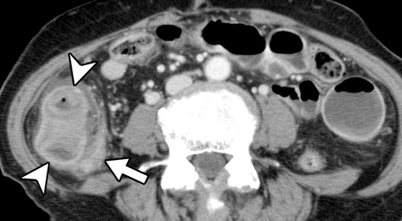

# Answer:

Focal area of luminal narrowing

Source: Internal Hernias in the Era of Multidetector CT_ Correlation of Imaging and Surgical Findings _ RadioGraphics.html

---Original Figure Caption:

Figure 14a.Pericecal hernia in an 83-year-old woman with a 1-day history of nausea and right lower abdominal pain.(a)Axial contrast-enhanced CT image shows incarcerated intestine with a saclike appearance (arrowheads) that displaces the ascending colon (arrow) medially.(b)ObliqueMPRCT image clearly shows the hernia orifice (arrows). Laparoscopic surgery showed incarcerated intestine in a hernia sac lateral to the ascending colon. (Case courtesy of Keigo Yasumasa, MD, JCHO Osaka Hospital, Osaka, Japan.)

# Question 22:

A patient presents with postprandial chest fullness but no symptoms of reflux. A radiological examination is provided in the figure. What postoperative complication is likely present in this patient?

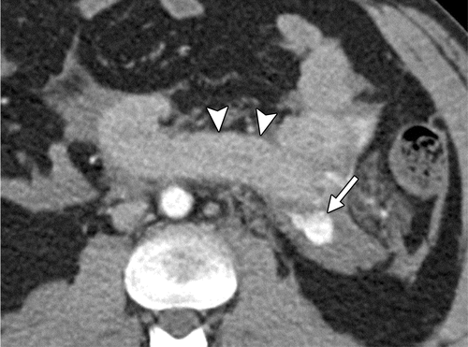

# Answer:

Recurrent hernia

Source: CT Findings of Acute Small-Bowel Entities _ RadioGraphics.html

---Original Figure Caption:

Figure 19b.Surgically-proven traumatic jejunal perforation in two patients who each presented after a motor vehicle collision.(a)Axial intravenous contrast-enhanced CT image in a 24-year-old man shows diffuse long-segment jejunal mural hyperenhancement with associated mesenteric edema, triangular fluid within the leaves of the mesentery (arrows), and hemoperitoneum.(b)Axial intravenous contrast-enhanced CT image in a 27-year-old man shows focal perforation in a jejunal segment with mural hyperenhancement (arrowheads) and active mesenteric arterial extravasation (arrow), corresponding to mesenteric injury at the level of the ligament of Treitz.

# Question 23:

A 54-year-old woman presents with a history of persistent heartburn and dysphagia. A CT scan is provided. What nonspecific finding might you deduce from the CT image?

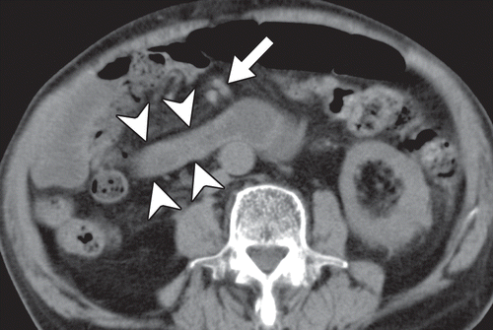

# Answer:

Marked circumferential wall thickening

Source: Internal Hernias in the Era of Multidetector CT_ Correlation of Imaging and Surgical Findings _ RadioGraphics.html

---Original Figure Caption:

Figure 7a.Right paraduodenal hernia in an 87-year-old man with a 1-day history of abdominal distention.(a)Axial nonenhanced CT image shows the proximal jejunum (arrowheads) posterolateral to the superior mesenteric artery and superior mesenteric vein (arrow).(b)Intraoperative photograph (left anterolateral view) after reduction shows the fossa of Waldeyer (arrows) just behind the root of the small bowel mesentery (blue *) and in front of the posterior parietal peritoneum (yellow *). The hernia orifice was closed with sutures.F= surgeon’s finger, green * = transverse mesocolon. (Case courtesy of Shinpei Ishikawa, MD, Perfect Liberty Hospital, Tondabayashi, Japan.)

# Question 24:

A 40-year-old woman presents with a 6-day history of abdominal pain and vomiting. Based on the intraoperative photograph provided, what is the most likely diagnosis?

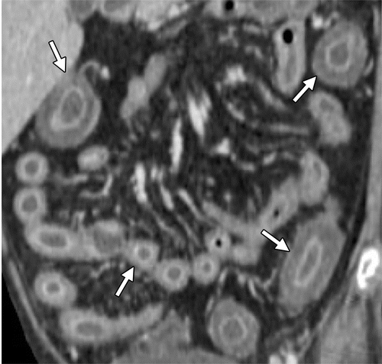

# Answer:

Falciform ligament hernia

Source: CT Findings of Acute Small-Bowel Entities _ RadioGraphics.html

---Original Figure Caption:

Figure 12b.GVHD in a 21-year-old woman with a history of myeloid sarcoma who presented with neutropenic fever 73 days after undergoing allogeneic stem cell transplantation. Axial(a)and coronal(b)intravenous contrast-enhanced CT images show diffuse bowel wall edema with a target appearance (arrows), resulting in diffuse luminal narrowing. The results of an endoscopic biopsy confirmed steroid-refractory GVHD.

# Question 25:

A 59-year-old woman presents with right lower abdominal pain. Based on the volume-rendered CT images provided, what is the likely diagnosis?

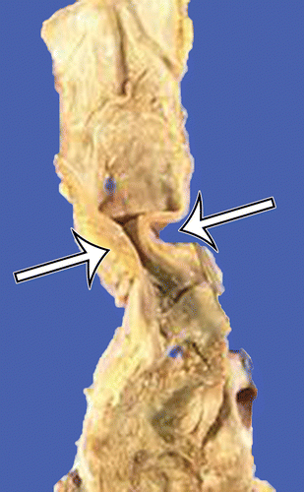

# Answer:

Transmesenteric hernia

Source: Role of Multimodality Imaging in Gastroesophageal Reflux Disease and Its Complications, with Clinical and Pathologic Correlation _ RadioGraphics.html

---Original Figure Caption:

Figure 11b.Peptic stricture.(a)Photomicrograph of the esophagus shows diffuse deposition of pink-stained fibrous tissue (curved arrows) in the splayed muscularis propria (straight arrow). There is lymphocytic infiltration of the lamina propria and epithelium (circle), which is now composed of glands containing goblet cells (arrowheads), indicative of chronic inflammation and intestinal metaplasia. (H-E stain; original magnification, ×40.)(b)Photograph of a gross specimen shows a focal area of luminal narrowing (arrows) just above the squamocolumnar junction.(c)Endoscopic image shows a focal area of smooth narrowing (arrow) adjacent to nodular reddened mucosa, consistent with erosive esophagitis. Note the finger-like projections of salmon-colored velvety mucosa (*), consistent with areas of Barrett esophagus.(d)Prone single-contrast radiograph shows smooth concentric narrowing of the midesophagus (arrows) with a tiny outpouching of contrast material (intramural pseudodiverticulosis).

# Question 26:

A 32-year-old pregnant woman is undergoing an ultrasound scan during her 5th week of gestation. In the scan, the radiologist identifies the embryologic development of the dorsal and ventral mesentery. Based on the figure, which part of the ventral mesentery is developing into the falciform ligament?

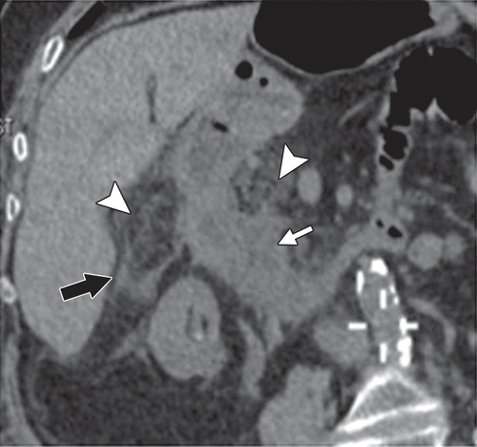

# Answer:

Ventral part of the ventral mesentery

Source: Imaging of Drug-induced Complications in the Gastrointestinal System _ RadioGraphics.html

---Original Figure Caption:

Figure 5a.NSAIDduodenitis in a 90-year-old woman taking a high-dose nonselectiveNSAID(1000 mg of naproxen twice a day).(a)Oblique coronal nonenhanced multiplanar reformatted CT image shows thickening of the duodenal wall (white arrow) and inflammatory stranding in the adjacent fat (arrowheads). A small amount of free fluid (black arrow) is also seen.(b)EGDimage shows a large circumferential ulcer in the duodenal bulb. Pathologic analysis showed active duodenitis with granulation tissue and ulceration.

# Question 27:

A 78-year-old woman presents with right-sided abdominal pain. An axial intravenous contrast-enhanced CT image is provided. What foreign object can be seen in the image?

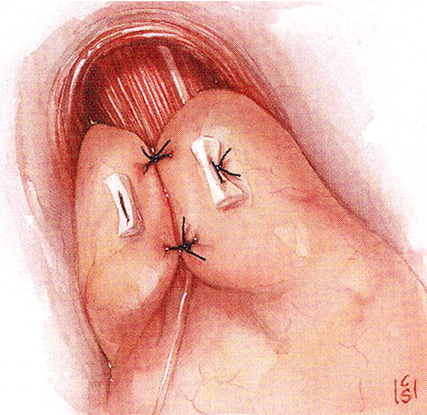

# Answer:

Thin bone

Source: Surgical Approach to Gastroesophageal Reflux Disease_ What the Radiologist Needs to Know _ RadioGraphics.html

---Original Figure Caption:

Figure 15b.Nissen fundoplication.(a)Drawing illustrates the fundus wrapped posteriorly around the distal esophagus and lower esophageal sphincter.(b)Drawing illustrates the fundus sutured anteriorly, making a complete 360° wrap. Note that the wrap extends for approximately 2–3 cm, encircles the lower esophageal sphincter, and lies below the level of the diaphragm. At least one of the sutures involves the esophageal wall to prevent slippage. If the esophageal hiatus is enlarged, the crura are approximated. (Reprinted, with permission, from reference,25.)

# Question 28:

A 74-year-old man presents with a 1-day history of right lower abdominal pain. Based on the intraoperative photograph provided, what structure is incarcerated into the right supravesical fossa?

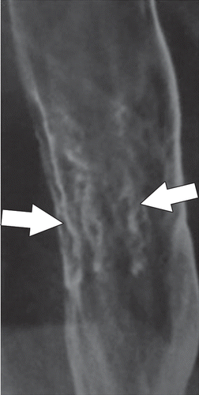

# Answer:

Ileum

Source: Imaging of Drug-induced Complications in the Gastrointestinal System _ RadioGraphics.html

---Original Figure Caption:

Figure 1d.Pill esophagitis.(a)Image from esophagogastroduodenoscopy (EGD) in a 74-year-old woman taking oral iron supplements who presented with odynophagia shows pill fragments stuck along the mucosa and linear and superficial ulcers (arrows). Pathologic analysis revealed iron-positive material.(b)Double-contrast esophagram in a 26-year-old woman taking tetracycline who presented with dysphagia shows a radiolucent round filling defect with a thin rim of barium (arrow). The finding represents a superficial ulcer with surrounding edema.(c)Double-contrast esophagram (profile view) in a 59-year-old man taking clindamycin who presented with dysphagia shows an elongated, flat, plaquelike filling defect (arrow) consistent with an ulcer.(d)Barium esophagram in a 72-year-old woman taking alendronate who presented with dysphagia shows a cluster of linear erosions (arrows) in the mid esophagus.

# Question 29:

A patient presents with postoperative dysphagia following a Nissen fundoplication. Based on the figure provided, what abnormality could be causing the patient's symptoms?

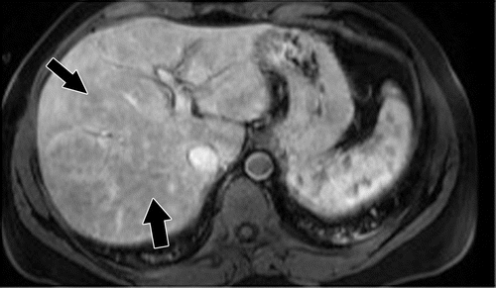

# Answer:

Marked narrowing from the wrap

Source: Imaging of Drug-induced Complications in the Gastrointestinal System _ RadioGraphics.html

---Original Figure Caption:

Figure 11b.Cholestatic liver injury in a 37-year-old man 2 days after starting treatment with azithromycin. Axial T2-weighted(a)and T1-weighted(b)contrast-enhanced MR images show periportal edema (arrows ina) and heterogeneous arterial enhancement (arrows inb). No biliary duct dilatation is seen. Liver biopsy revealed cholestasis and focal feathery degeneration of the hepatocytes, findings indicative of mild steatosis.

# Question 30:

A 55-year-old woman presents with recurrent heartburn and dysphagia. Based on the upright radiograph of the GEJ provided in the figure, what type of hiatal hernia is seen?

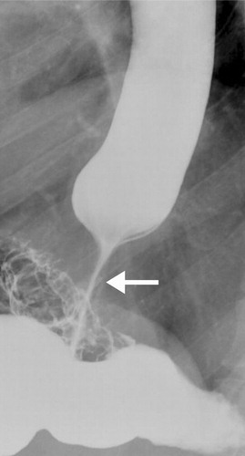

# Answer:

Type III hiatal hernia

Source: Surgical Approach to Gastroesophageal Reflux Disease_ What the Radiologist Needs to Know _ RadioGraphics.html

---Original Figure Caption:

Figure 25.Dysphagia. Tight Nissen fundoplication in a patient who presented with dysphagia beyond the immediate postoperative period. Spot radiograph reveals a severely narrowed distal esophagus and GEJ (arrow). The barium tablet was obstructed by this too-tight wrap.

# Question 31:

A 57-year-old patient presents with chronic heartburn and dysphagia. An endoscopic image is provided. According to the Los Angeles classification, how would you grade the severity of this patient's erosive reflux esophagitis?

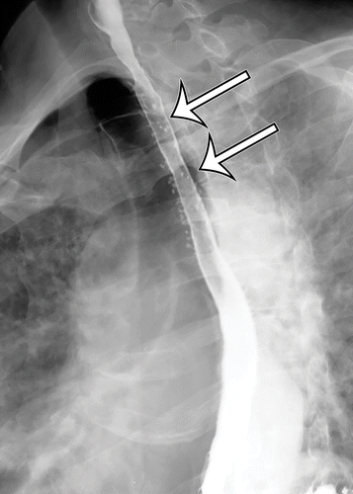

# Answer:

Grade D

Source: Role of Multimodality Imaging in Gastroesophageal Reflux Disease and Its Complications, with Clinical and Pathologic Correlation _ RadioGraphics.html

---Original Figure Caption:

Figure 11d.Peptic stricture.(a)Photomicrograph of the esophagus shows diffuse deposition of pink-stained fibrous tissue (curved arrows) in the splayed muscularis propria (straight arrow). There is lymphocytic infiltration of the lamina propria and epithelium (circle), which is now composed of glands containing goblet cells (arrowheads), indicative of chronic inflammation and intestinal metaplasia. (H-E stain; original magnification, ×40.)(b)Photograph of a gross specimen shows a focal area of luminal narrowing (arrows) just above the squamocolumnar junction.(c)Endoscopic image shows a focal area of smooth narrowing (arrow) adjacent to nodular reddened mucosa, consistent with erosive esophagitis. Note the finger-like projections of salmon-colored velvety mucosa (*), consistent with areas of Barrett esophagus.(d)Prone single-contrast radiograph shows smooth concentric narrowing of the midesophagus (arrows) with a tiny outpouching of contrast material (intramural pseudodiverticulosis).

# Question 32:

A 58-year-old woman presents with a 1-day history of intermittent abdominal pain and vomiting. She has a history of three normal pregnancies. Based on the provided axial contrast-enhanced CT images, what type of hernia is most likely present?

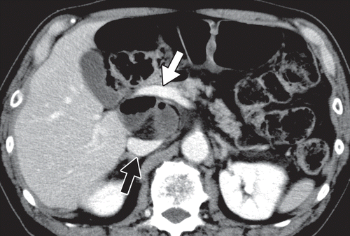

# Answer:

Broad ligament hernia

Source: Internal Hernias in the Era of Multidetector CT_ Correlation of Imaging and Surgical Findings _ RadioGraphics.html

---Original Figure Caption:

Figure 11a.Foramen of Winslow hernia in a 74-year-old man with intermittent abdominal pain.(a)Axial contrast-enhanced CT image shows mesenteric vessels and a cluster of intestine between the inferior vena cava (black arrow) and portal vein (white arrow).(b)Volume-rendered CT image of the intestine (orange), venous system (dark blue), and portal venous system (light blue) shows a short segment of intestine in the superior recess of the lesser sac (arrow) through the foramen of Winslow. The herniation was spontaneously reduced after placement of a long nasointestinal tube. (Case courtesy of Shigeru Furui, MD, and Asako Yamamoto, MD, Teikyo University School of Medicine, Tokyo, Japan.)

# Question 33:

A 60-year-old woman has presented with bloating and has a history of long-term NSAID use. Based on the capsule endoscopy image provided, what condition should be considered in the differential diagnosis?

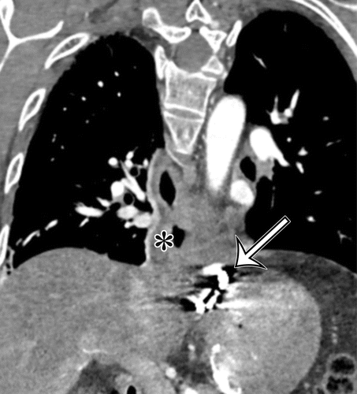

# Answer:

Mucosal diaphragm disease

Source: Role of Multimodality Imaging in Gastroesophageal Reflux Disease and Its Complications, with Clinical and Pathologic Correlation _ RadioGraphics.html

---Original Figure Caption:

Figure 8c.Surgically placed magnetic device to augment the LES.(a)Frontal radiograph shows a ring of round metallic beads (arrow) in the expected subdiaphragmatic location of the EGJ. With swallowing, the pressure associated with the propelled bolus opens the ring, with widening of the space between the magnetic beads.(b)Upright double-contrast esophagram shows widening of the space between the magnetic beads (arrow).(c)CT image reconstructed in the coronal oblique plane to better demonstrate the EGJ shows the metallic areas of attenuation with associated streak artifact (arrow). Note the distal esophageal wall thickening (*).

# Question 34:

A 61-year-old man presents with progressive dysphagia. An axial contrast-enhanced CT image of the patient's esophagus is provided. Based on the imaging findings, what is the most likely T stage of this patient's esophageal adenocarcinoma?

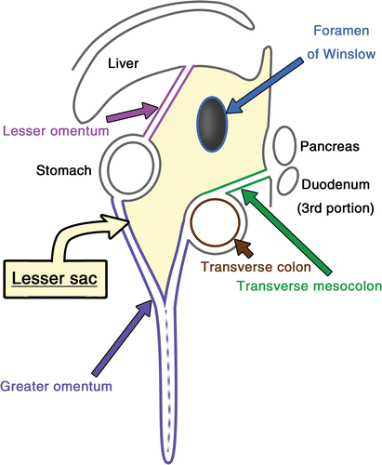

# Answer:

T3

Source: Internal Hernias in the Era of Multidetector CT_ Correlation of Imaging and Surgical Findings _ RadioGraphics.html

---Original Figure Caption:

Figure 10.Sagittal diagram (left lateral view) of the structures around the lesser sac. The foramen of Winslow, lesser omentum, greater omentum, and transverse mesocolon are potential orifices for lesser sac hernias. The transverse colon is located posterosuperior to the greater omentum and anteroinferior to the transverse mesocolon.

# Question 35:

A 59-year-old woman presents with right lower abdominal pain. An axial contrast-enhanced CT image is provided. What specific abnormality of the mesenteric vessels can be observed?

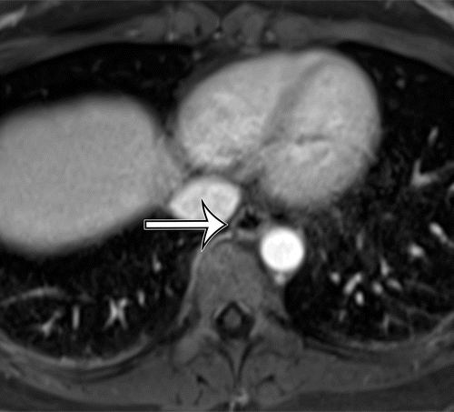

# Answer:

Radial distribution of converging, engorged, twisting mesenteric vessels

Source: Role of Multimodality Imaging in Gastroesophageal Reflux Disease and Its Complications, with Clinical and Pathologic Correlation _ RadioGraphics.html

---Original Figure Caption:

Figure 3d.Normal esophagus.(a)Contrast-enhanced CT image shows a normal-thickness (<5 mm) homogeneously enhancing esophageal wall (straight arrow) surrounding a small amount of intraluminal air, with a distinct surrounding fat plane (curved arrow).(b)In-phase T1-weighted MR image shows the normal esophagus as a collapsed tubular structure of homogeneous low signal intensity (arrow).(c)Out-of-phase T1-weighted image shows the distinct margin between the outer esophageal wall (straight arrow) and surrounding fat (curved arrow).(d)Contrast-enhanced T1-weighted image from volumetric interpolated breath-hold examination (VIBE) imaging shows normal wall thickness with homogeneous mural enhancement (arrow).(e)T2-weighted image shows the multilayered appearance of the normal esophagus, with the normal mucosa seen as a thin layer of intermediate signal intensity (white arrowhead) surrounded by an outer thin layer of low-signal-intensity muscularis propria (black arrowhead).

# Question 36:

A patient presents with symptoms suggestive of a hiatal hernia. Upon reviewing the provided radiograph, what normal anatomical structure can mimic a type I hiatal hernia?

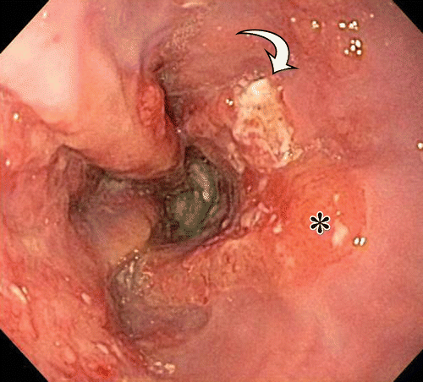

# Answer:

Esophageal vestibule

Source: Role of Multimodality Imaging in Gastroesophageal Reflux Disease and Its Complications, with Clinical and Pathologic Correlation _ RadioGraphics.html

---Original Figure Caption:

Figure 15b.Esophageal adenocarcinoma.(a)Photomicrograph shows the changes associated with progression to adenocarcinoma, with back-to-back irregularly shaped glands of varying size containing hyperchromatic nuclei (curved arrow) within the mucosa and infiltrating into the lamina propria and muscularis (straight arrow). Note the extensive fibrosis (*). (H-E stain; original magnification, ×100.)(b, c)Endoscopic images show flat mucosal nodules (arrow inb) on a background of Barrett esophagus (* inb) and a larger polypoid intraluminal mass (arrow inc) causing luminal narrowing.(d)Endoscopic US image accurately shows the depth of tumor invasion. The hyperechoic tumor (*) disrupts alternating rings of hyperechoic superficial mucosa, hypoechoic deep mucosa, hyperechoic submucosa, and hypoechoic muscularis propria (arrowheads), with minimal extension into the hyperechoic adventitia.

# Question 37:

A coronal intravenous contrast-enhanced CT image of a 56-year-old woman with symptoms of abdominal pain, cramping, and diarrhea is provided. Based on the image, which characteristic signs of active inflammatory bowel disease can you identify?

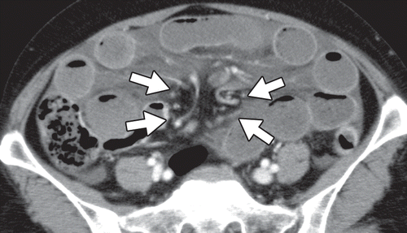

# Answer:

Marked wall thickening, mucosal hyperenhancement, the comb sign representing mesenteric engorgement, luminal narrowing and upstream dilatation

Source: Internal Hernias in the Era of Multidetector CT_ Correlation of Imaging and Surgical Findings _ RadioGraphics.html

---Original Figure Caption:

Figure 8a.Transmesenteric hernia in a 59-year-old woman with right lower abdominal pain.(a)Axial contrast-enhanced CT image shows radial distribution of converging, engorged, twisting mesenteric vessels (arrows). No sac is observed.(b, c)Volume-rendered CT images show incarcerated intestine (blue arrows inb) in the ventral portion of the peritoneal cavity. Converging mesenteric vessels pass through a defect (green arrows inc) in the mesentery of the terminal ileum (yellow arrow inc).(d)Intraoperative photograph (anterior view) shows incarcerated intestine (blue arrows) through a 19-cm-diameter defect (green arrows) in the mesentery of the terminal ileum (yellow arrow). Approximately 190 cm of gangrenous small intestine was resected, and the defect was closed with sutures. (Fig 8a–8c courtesy of Sakae Nagaoka, MD, Japanese Red Cross Medical Center, Tokyo, Japan, and Chikara Shirata, MD, Graduate School of Medicine, University of Tokyo, Tokyo, Japan. Fig 8d adapted and reprinted, with permission, from reference31.)

# Question 38:

A 56-year-old man with a history of chronic gastroesophageal reflux disease presents with dysphagia. His endoscopic images are provided in the figure. What is the most likely diagnosis based on the findings?

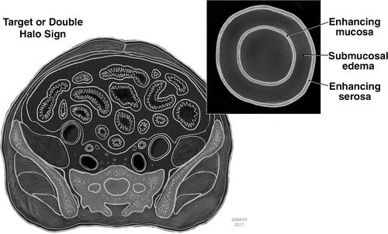

# Answer:

Barrett esophagus

Source: CT Findings of Acute Small-Bowel Entities _ RadioGraphics.html

---Original Figure Caption:

Figure 1c.Target or double halo sign.(a, b)Coronal(a)and axial(b)intravenous contrast-enhanced CT images in a 59-year-old woman with end-stage renal disease and small vessel ischemia show enhancement of the inner mucosa and outer muscularis propria/serosa (arrows), with a middle layer of low-attenuating submucosal edema. Note the reactive ascites and interloop edema owing to ischemic change of the jejunum.(c)Illustration shows an axial view of the inner mucosa and outer muscularis propria/serosa, with an inset labeling a double halo or target sign. (Reprinted, with permission, from Mayo Foundation for Medical Education and Research.)

# Question 39:

A 55-year-old patient presents with dysphagia following a surgical procedure for gastroesophageal reflux disease. Based on the radiograph in the figure, what are the two key radiographic findings that suggest normal postoperative changes?

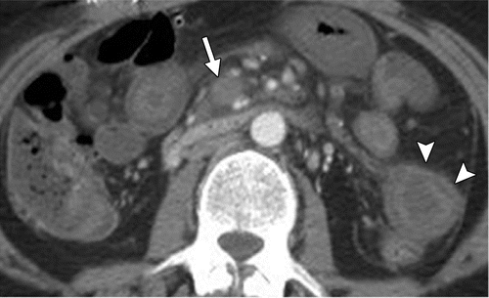

# Answer:

Filling defect in the fundus and tapered narrowing of the distal esophagus and GEJ

Source: CT Findings of Acute Small-Bowel Entities _ RadioGraphics.html

---Original Figure Caption:

Figure 4a.Acute mesenteric venous ischemia in a 43-year-old woman with positive test results for lupus anticoagulant who presented with acute abdominal pain. Axial(a)and coronal(b)intravenous contrast-enhanced CT images show an occlusive thrombus within the superior mesenteric vein (white arrow) and its jejunal branches, with several loops of thick-walled jejunum (arrowheads) that show marked mural edema and a target appearance of the bowel, which is poorly enhancing. Note the mesenteric edema and fluid (black arrow inb), common features of mesenteric venous ischemia.

# Question 40:

A 51-year-old woman, who underwent low anterior resection for rectal cancer 2 months earlier, presents with severe abdominal pain. Based on the axial intravenous contrast-enhanced CT image provided, what is the likely diagnosis?

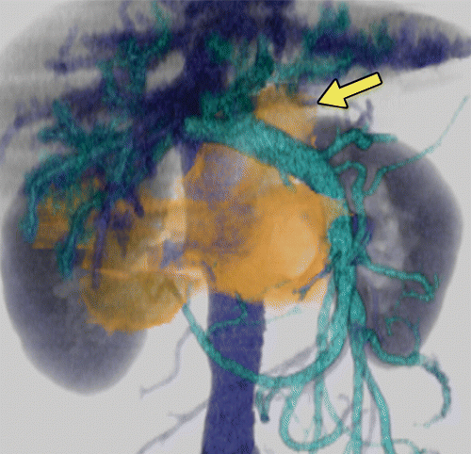

# Answer:

Closed-loop small-bowel obstruction

Source: Internal Hernias in the Era of Multidetector CT_ Correlation of Imaging and Surgical Findings _ RadioGraphics.html

---Original Figure Caption:

Figure 11b.Foramen of Winslow hernia in a 74-year-old man with intermittent abdominal pain.(a)Axial contrast-enhanced CT image shows mesenteric vessels and a cluster of intestine between the inferior vena cava (black arrow) and portal vein (white arrow).(b)Volume-rendered CT image of the intestine (orange), venous system (dark blue), and portal venous system (light blue) shows a short segment of intestine in the superior recess of the lesser sac (arrow) through the foramen of Winslow. The herniation was spontaneously reduced after placement of a long nasointestinal tube. (Case courtesy of Shigeru Furui, MD, and Asako Yamamoto, MD, Teikyo University School of Medicine, Tokyo, Japan.)

# Question 41:

A 35-year-old woman presents with left lower abdominal pain. Based on the 3DCT angiogram provided in the figure, what vessels can be seen running in the hernia orifice?

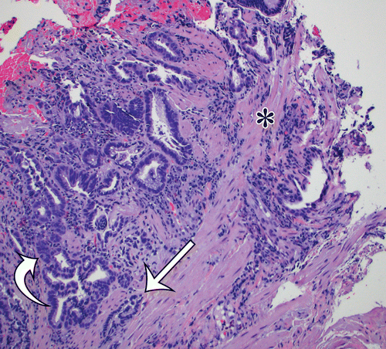

# Answer:

Mesenteric vessels

Source: Role of Multimodality Imaging in Gastroesophageal Reflux Disease and Its Complications, with Clinical and Pathologic Correlation _ RadioGraphics.html

---Original Figure Caption:

Figure 15a.Esophageal adenocarcinoma.(a)Photomicrograph shows the changes associated with progression to adenocarcinoma, with back-to-back irregularly shaped glands of varying size containing hyperchromatic nuclei (curved arrow) within the mucosa and infiltrating into the lamina propria and muscularis (straight arrow). Note the extensive fibrosis (*). (H-E stain; original magnification, ×100.)(b, c)Endoscopic images show flat mucosal nodules (arrow inb) on a background of Barrett esophagus (* inb) and a larger polypoid intraluminal mass (arrow inc) causing luminal narrowing.(d)Endoscopic US image accurately shows the depth of tumor invasion. The hyperechoic tumor (*) disrupts alternating rings of hyperechoic superficial mucosa, hypoechoic deep mucosa, hyperechoic submucosa, and hypoechoic muscularis propria (arrowheads), with minimal extension into the hyperechoic adventitia.

# Question 42:

A 55-year-old patient presents with difficulty swallowing. You are examining a photomicrograph of the patient's normal esophagus. What specific structure is indicated by the arrow in the provided figure?

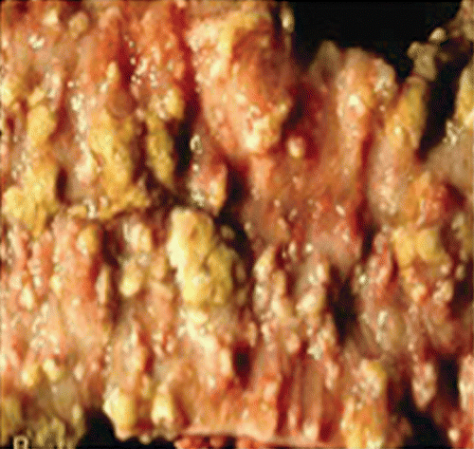

# Answer:

Surface composed of a few flattened cells devoid of nuclei

Source: Imaging of Drug-induced Complications in the Gastrointestinal System _ RadioGraphics.html

---Original Figure Caption:

Figure 10c.Pseudomembranous colitis.(a)Image from colonoscopy in a 52-year-old man who presented with profuse diarrhea shows superficial ulcerations with overlying yellow-white plaques that correspond to pseudomembranes.(b)Abdominal radiograph in a 59-year-old woman who presented with diarrhea shows diffuse thickening of the colon wall with thumbprinting (arrows). The patient was taking cephalosporin for a urinary tract infection.(c)Pathologic specimen from colon resection in a 44-year-old woman with toxemia shows colonic mucosa with diffuse active colitis and polypoid pseudomembranes.(d)Axial contrast-enhanced CT image in a 62-year-old woman with a history of pneumonia treated with clindamycin who presented with diarrhea shows pseudomembranous colitis with pancolitis. There is marked diffuse thickening of the colon wall with submucosal edema (white arrow) and diffuse mucosal hyperemia (black arrow).

# Question 43:

In a clinical scenario where a patient is swallowing, what happens to the LES as visualized in the provided figure?

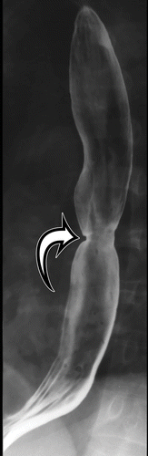

# Answer:

The LES relaxes

Source: Role of Multimodality Imaging in Gastroesophageal Reflux Disease and Its Complications, with Clinical and Pathologic Correlation _ RadioGraphics.html

---Original Figure Caption:

Figure 14c.Barrett esophagus.(a, b)Endoscopic images show a short segment(a)and a longer segment(b)of salmon-colored velvety mucosa (curved arrow) extending cephalically from the EGJ, defined as the most proximal extent of the gastric folds. Note the normal smooth pale appearance of the normal squamous mucosa (*) and the refluxate within the small hiatal hernia (straight arrow ina).(c, d)Double-contrast esophagrams show short (arrow inc) and long smooth tapered (arrows ind) midesophageal strictures, the most specific radiographic finding for Barrett esophagus. Note the granular appearance of the distal esophageal mucosa(c)and the small hiatal hernia(d).

# Question 44:

A 55-year-old man presents with dysphagia. An out-of-phase T1-weighted MRI of his esophagus is performed. What would be the expected appearance of the normal esophageal wall and surrounding fat in this imaging technique?

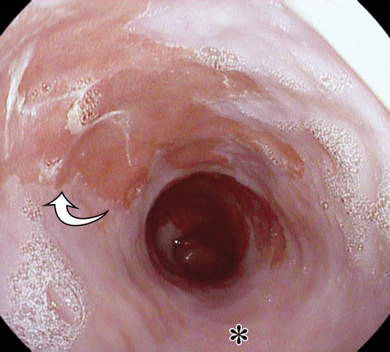

# Answer:

Distinct margin between the outer esophageal wall and surrounding fat

Source: Role of Multimodality Imaging in Gastroesophageal Reflux Disease and Its Complications, with Clinical and Pathologic Correlation _ RadioGraphics.html

---Original Figure Caption:

Figure 14b.Barrett esophagus.(a, b)Endoscopic images show a short segment(a)and a longer segment(b)of salmon-colored velvety mucosa (curved arrow) extending cephalically from the EGJ, defined as the most proximal extent of the gastric folds. Note the normal smooth pale appearance of the normal squamous mucosa (*) and the refluxate within the small hiatal hernia (straight arrow ina).(c, d)Double-contrast esophagrams show short (arrow inc) and long smooth tapered (arrows ind) midesophageal strictures, the most specific radiographic finding for Barrett esophagus. Note the granular appearance of the distal esophageal mucosa(c)and the small hiatal hernia(d).

# Question 45:

A 53-year-old woman presents with recurrent episodes of right upper quadrant abdominal pain. A CT scan was performed and is provided in the figure. Based on the imaging findings, what could be the possible diagnosis?

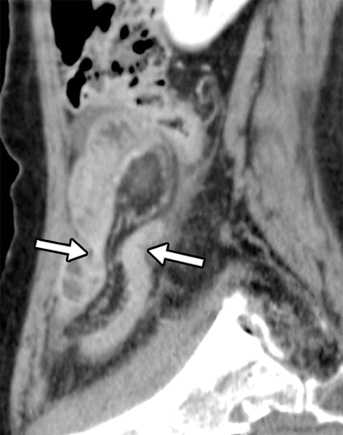

# Answer:

Xanthogranulomatous cholecystitis

Source: Internal Hernias in the Era of Multidetector CT_ Correlation of Imaging and Surgical Findings _ RadioGraphics.html

---Original Figure Caption:

Figure 14b.Pericecal hernia in an 83-year-old woman with a 1-day history of nausea and right lower abdominal pain.(a)Axial contrast-enhanced CT image shows incarcerated intestine with a saclike appearance (arrowheads) that displaces the ascending colon (arrow) medially.(b)ObliqueMPRCT image clearly shows the hernia orifice (arrows). Laparoscopic surgery showed incarcerated intestine in a hernia sac lateral to the ascending colon. (Case courtesy of Keigo Yasumasa, MD, JCHO Osaka Hospital, Osaka, Japan.)

# Question 46:

A 56-year-old patient with a history of Gastroesophageal reflux disease (GERD) presents with difficulty swallowing. Based on the radiographic findings shown in the figure, what complication of GERD is likely to be causing the patient's symptoms?

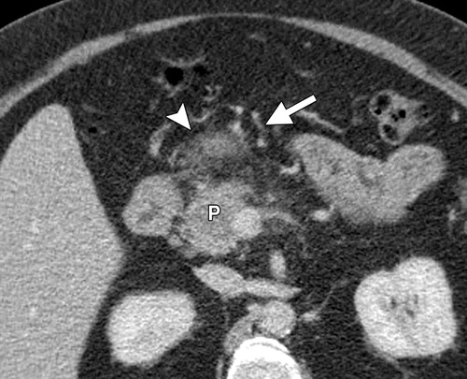

# Answer:

Reflux stricture

Source: Peritoneal and Retroperitoneal Anatomy and Its Relevance for Cross-Sectional Imaging _ RadioGraphics.html

---Original Figure Caption:

Figure 6Transverse mesocolon metastasis in a 56-year-old man with pancreatic cancer. Axial CT image shows a pancreatic tumor(P)invading the transverse mesocolon (arrowhead). The tumor was deemed unresectable due to invasion and many small vessels (arrow) that make vascular control difficult.

# Question 47:

A 61-year-old male patient underwent heart transplantation and subsequently developed retroperitoneal hemorrhage. Based on the coronal reformatted CT image provided, which peritoneal space does not communicate with the pelvis?

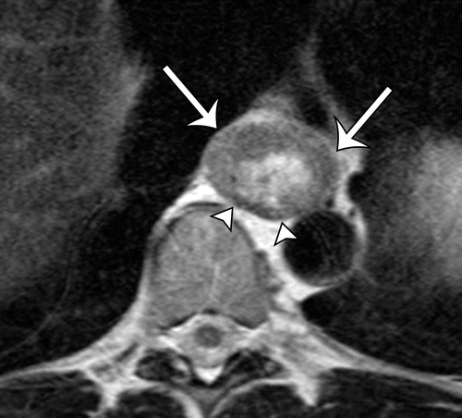

# Answer:

Right inframesocolic space

Source: Role of Multimodality Imaging in Gastroesophageal Reflux Disease and Its Complications, with Clinical and Pathologic Correlation _ RadioGraphics.html

---Original Figure Caption:

Figure 21a.Stage T3 esophageal adenocarcinoma.(a)T2-weighted MR image shows intermediate-signal-intensity tumor (arrows) replacing the normal layers of the esophageal wall and infiltrating through the muscularis propria, with blurring of the outer esophageal border. Arrowheads = intact muscularis propria along the posterior esophagus.(b)Photomicrograph matched to the same level shows tumor involving the submucosa and muscularis (arrows), with intact muscularis along the posterior wall (arrowheads). (H-E stain; original magnification, ×4.) (Case courtesy of Angela M. Riddell, MD, Royal Marsden Hospital, London, England.)

# Question 48:

A 74-year-old man presents with intermittent abdominal pain. Based on the volume-rendered CT image provided, what type of hernia is depicted and which anatomical structure is it passing through?

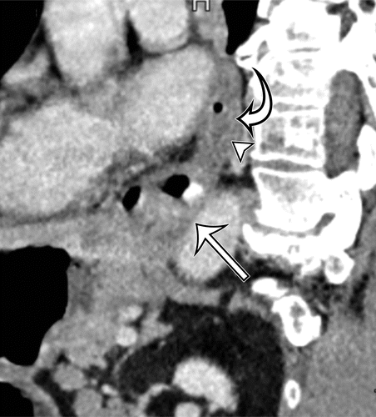

# Answer:

Foramen of Winslow hernia

Source: Role of Multimodality Imaging in Gastroesophageal Reflux Disease and Its Complications, with Clinical and Pathologic Correlation _ RadioGraphics.html

---Original Figure Caption:

Figure 10c.Reflux esophagitis.(a)Axial nonenhanced CT image shows marked circumferential wall thickening (arrow), which is a nonspecific finding but correlates well with the presence of reflux esophagitis.(b)Axial contrast-enhanced CT image obtained with gaseous luminal distention better shows circumferential wall thickening with mucosal enhancement (arrow) and submucosal hypoenhancement (arrowhead), comprising the target sign, indicative of submucosal inflammation and edema.(c)Sagittal oblique contrast-enhanced CT image along the axis of the distal esophagus shows supradiaphragmatic positioning of the EGJ (straight arrow) with circumferential wall thickening of the distal esophageal wall, consistent with hiatal hernia and known reflux esophagitis. Note the presence of the target sign, composed of enhancing mucosa (curved arrow) and hypoenhancing submucosa (arrowhead).(d)Fast HASTE (half-Fourier acquisition single-shot turbo spin-echo) T2-weighted image shows wall thickening of the distal esophagus (straight arrow) with high-signal-intensity mural edema (curved arrow).

# Question 49:

A 46-year-old man with metastatic colon carcinoma presents with epigastric pain after his fifth cycle of Folfox chemotherapy. Based on the axial contrast-enhanced CT image provided, what is the most likely diagnosis?

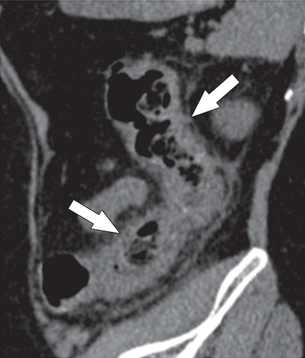

# Answer:

Chemotherapy-related pancreatitis

Source: Imaging of Drug-induced Complications in the Gastrointestinal System _ RadioGraphics.html

---Original Figure Caption:

Figure 9a.NSAID-related colitis in a 54-year-old woman taking a high-dose nonselectiveNSAID(6400–7000 mg of ibuprofen per day) who presented with diffuse abdominal pain.(a)Sagittal nonenhanced reformatted CT image shows marked thickening of the descending colon with adjacent inflammatory stranding and edema (arrows).(b)Image from correlative colonoscopy shows linear mucosal ulcerations and mucosal edema in the descending colon.

# Question 50:

A Fast HASTE T2-weighted image of a 55-year-old patient with persistent heartburn and discomfort is provided. Based on the provided figure, what are the two main findings observed?

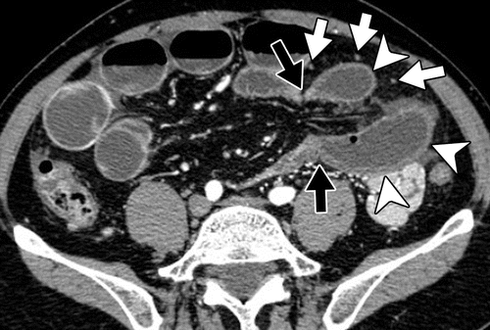

# Answer:

Wall thickening of the distal esophagus and high-signal-intensity mural edema

Source: Internal Hernias in the Era of Multidetector CT_ Correlation of Imaging and Surgical Findings _ RadioGraphics.html

---Original Figure Caption:

Figure 9.Transomental hernia in a 51-year-old man with gradually increasing abdominal pain. Axial contrast-enhanced CT image shows fluid-filled closed-loop intestine (arrowheads) and converging mesenteric vessels and fat in the hernia orifice (black arrows). Omental vessels (white arrows) running vertically are also seen near the incarcerated intestine and the hernia orifice. Surgery confirmed a transomental hernia. (Adapted and reprinted, with permission, from reference40.)